

Trello Screenshots

Software Developer - Music Player



Contents

End of day 1 of development. 2

Mid-way through day 3 of development. 3

End of day 4 of development. 4

# End of day 1 of development.

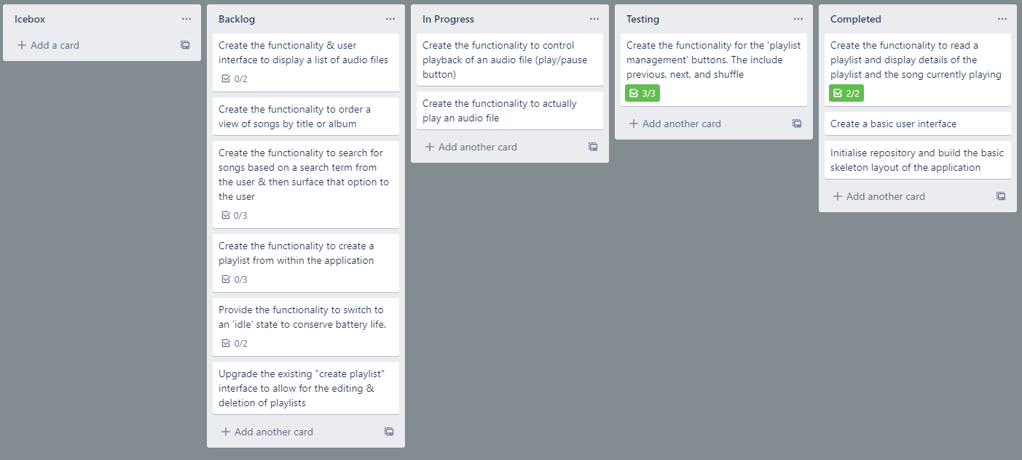

# Mid-way through day 3 of development.

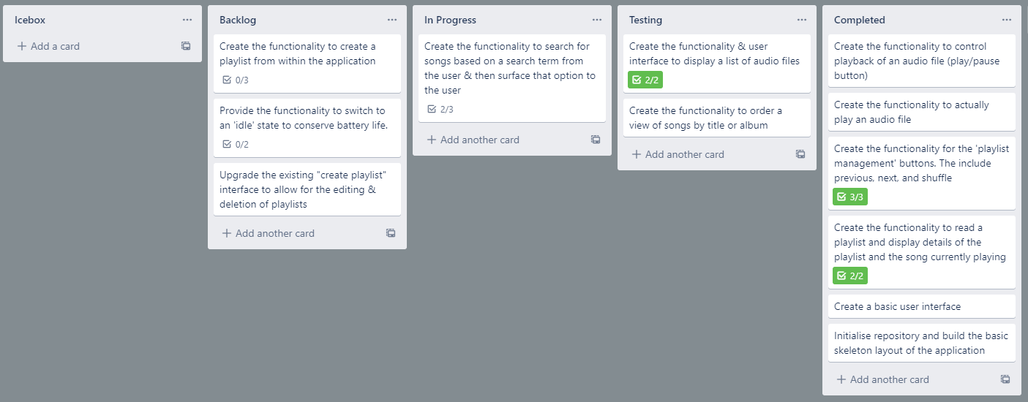

# End of day 4 of development.

The item in the Icebox was not a requirement of the application, but a feature I had hoped to squeeze into phase one of the development process that I was unable to.

